Ch.13 – Asexual reproduction in Flowering Plant
Vegetative propagation (P.13-5 to 13-10)

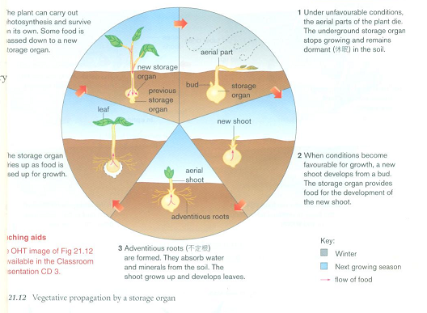
Under favourable conditions, the aerial parts of the plant die.
The underground storage organ stops growing and remains dormant in the soil.
2. When conditions become favourable for growth, a new shoot develops from a bud. The storage organ provides food for the development of the new shoot.
3. Adventitious roots are formed. They absorb water and minerals from the soil. The shoot grows up and develops leaves.
4. The storage organ dries up as food is used up for growth.
5. The plant can carry out photosynthesis and survive on its own. Some food is passed down to a new storage organ.

Exercise
- The following diagrams show three different types of storage organs for vegetative propagation of flowering plants.

Colour the diagrams according to the below instructions:
(i) the parts of the plant that developed in this growing season – green
(ii) the storage organ of the plant in the previous growing season – red
(iii) the new bud and new storage organ - yellow

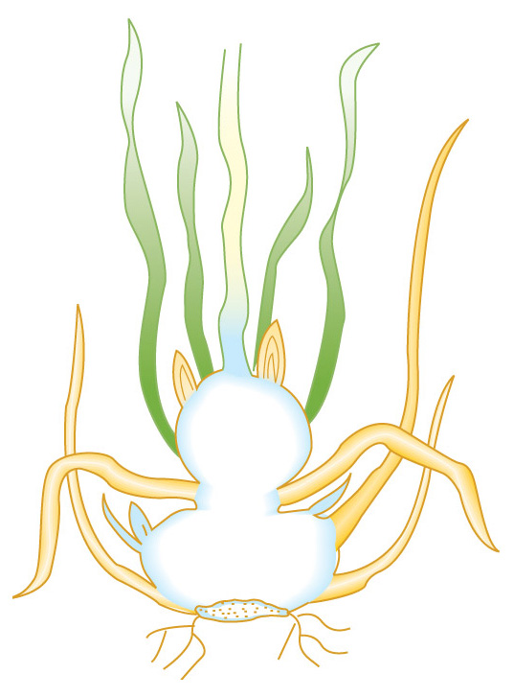
(a) Stem tuber (b) Bulb (c) Corm
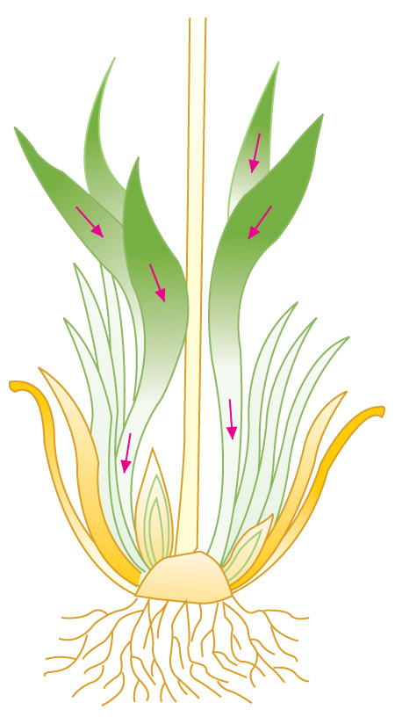
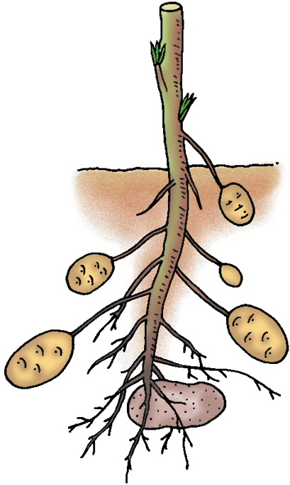

2. The diagrams below show the growth of a ginger rhizome.
In diagram (a), use red arrows to show how stored food is transported to the developing bud. In diagram (b), use blue arrows to show how food surplus is transported to the storage organ.

Diagram (a) Diagram (b)
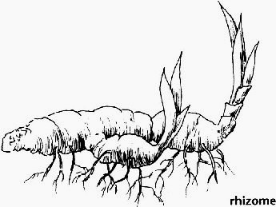
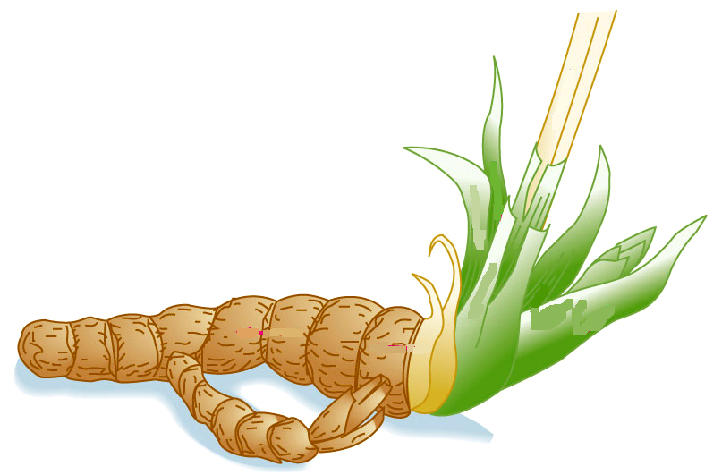

3. Arrange the following events in the correct sequence of vegetative propagation of a storage organ:

___________

A | A new shoot develops from a bud using food store in the storage organ.
B | The plant can photosynthesize and survive on its own. Some food is passed down to a new storage organ.
C | The aerial parts of the plant die. The underground storage organ remains dormant.
D | Adventitious roots are formed for absorbing water and minerals. The shoot grows up and develops leaves.
E | The old storage organ dies up as food is used up for growth.

4. Advantages and disadvantages of vegetative propagation in flowering plants:
Advantages | Disadvantages
A _________way to produce new plants | ___________can occur which causes competition for resources
Not require the help of _______________ or other plants | _______________ of the parent plants can easily be transmitted to the offspring
_______________ characters of the parent plants are passed to the offspring | Offspring cannot have new features to ____________ to any changing environmental conditions
 | ________________ characters will be passed to the offspring

